Form: Sample Submission Form
Sample for Sanitation Items
Item Code | Description | Sample Required | Sample Image from Supplier/Vendor
CO01105 | Wet Mop Cotton Floor Mop - 24 Inch with 4ft Long Handle | 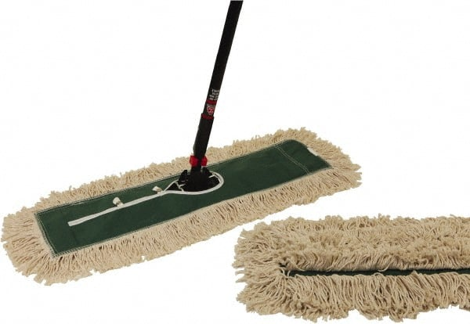
CO01108 | Rotary Mop - 360 degree Spin Rotating Pole & Bucket with 2 Microfiber heads – High Quality | 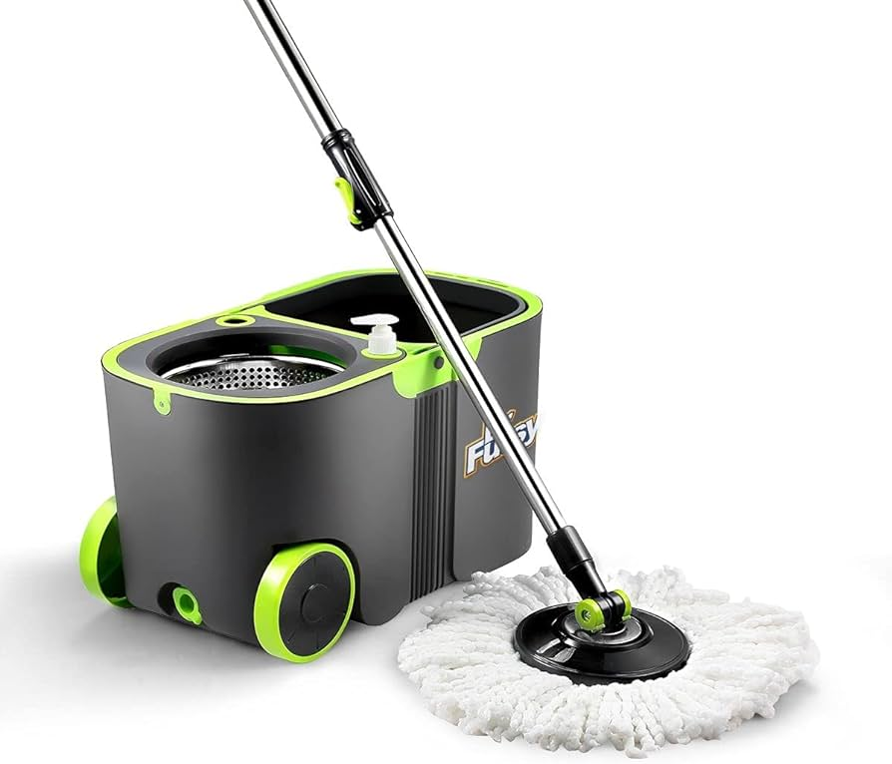
CO01109 | Cloth Piece - Microfibre Cloth Piece - Size 40 X 40 cm, Different Colours | 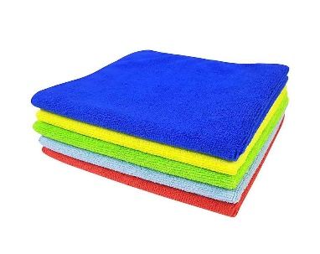
CO01110 | Cloth Piece - Wet and Dry Cotton Cleaning Cloth | 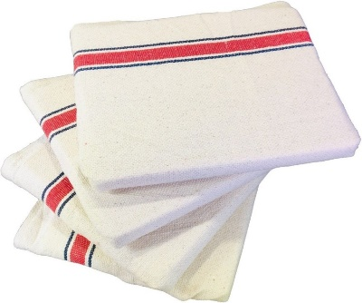
CO01112 | Rubber Hand Gloves (High quality), Different Colours | 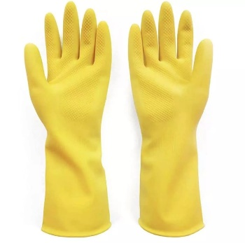
CO01117 | Garbage Plastic Bag (Large) - Swacleen Garbarge Bag (24"X30"), Black in colour (Thick) - 15 bags in Pkt | 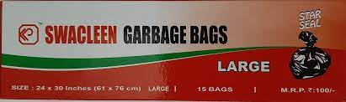
CO01118 | Garbage Plastic Bag (Small) - Swacleen Garbarge Bag (17"X19"), Black in colour (Thick) - 30 bags in Pkt | 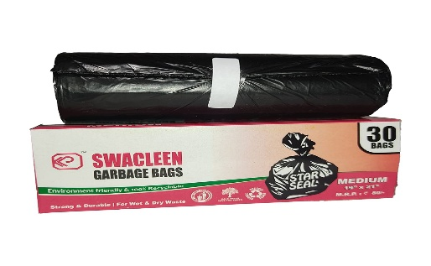
CO01122 | CROSS Citra Fresh (White Phenyl) - 500 ml | 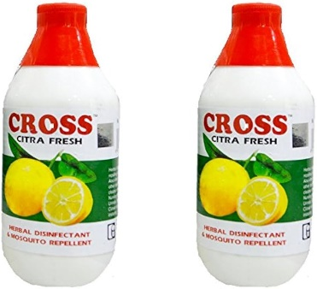
CO01133 | Foot Mat (PVC Coil Mats) | 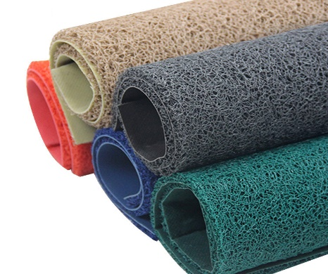
CO01134 | Foot Mat (Synthetic) | 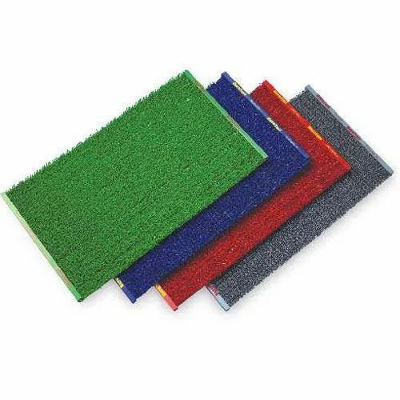
CO01135 | Foot Mat (PVC Grass Type) | 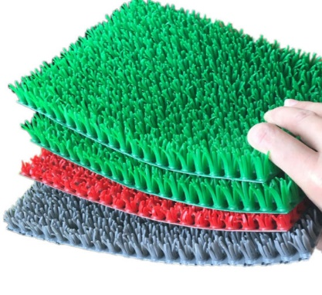

Sample for Sanitation Items
Item Code | Description | Sample | Sample Image from Supplier/Vendor
CO01052 | File (Ambassador Executive File) | 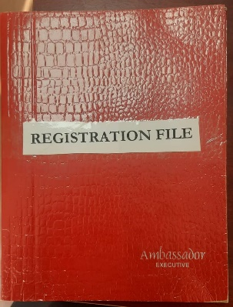
CO01053 | D. Ring File, A4 | 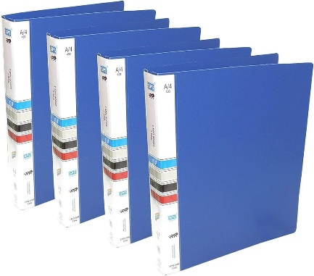
CO01055 | Horse File H - 423 Lever Arch File A4 - 28.5 x 35 x 5 cm | 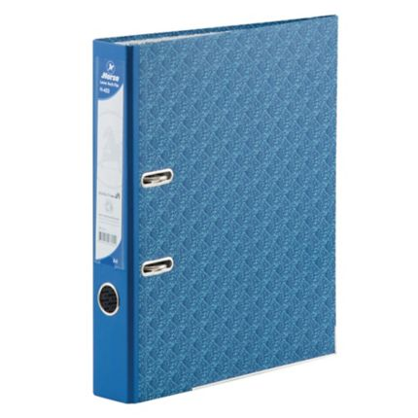
CO01056 | Horse File H - 423 Lever Arch File A4 - 28.5 x 35 x 8.5 cm | 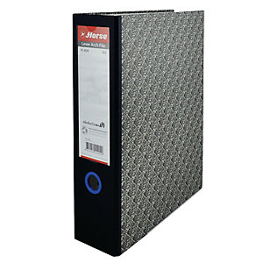
CO01057 | Plastic Folder File, A4 | 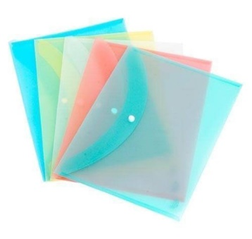

Name of the Bidder:

Sign and Seal of the Bidder

