Measurement for Existing pillars for 250Wp modules to be installed on these existing pillars at Latongla Telecom Station
Drawing 1:
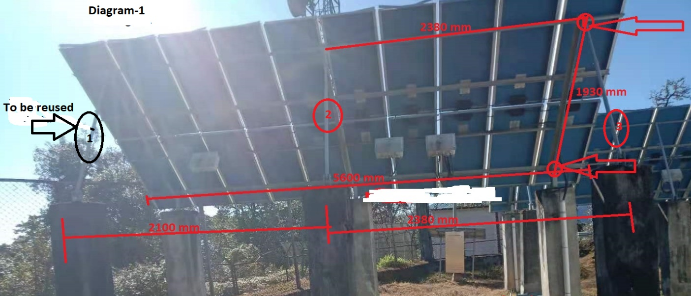

- Vendor to supply 250Wp Panels with structures and accessories complete which will mount on this existing pillars. The structure holes for nut and bolts should be adjustable enough.
- Vendor need not supply the structure which is shown in circle-1-3 above diagram (to be reused)
Drawing 2:

